

**Macau University of Science and Technology**

**Faculty of Innovation Engineering**

**School of Computer Science and Engineering**

**SE 252: Software Project Management**

**Software Project Proposal**

**Project Title**: *MustStudy*

**Submitted By**

* *[Liu KeTong 1210018831]*
* *[Li ZiXu 1220010081]*
* *[Zheng Ao 1220005554]*

**Submission Date**: *[Feb 15, 2025]*

#### **Project title: Must Study**

A question-and-answer community platform aimed at students of Australia University, integrating Q&A, resource sharing, and AI assistant functions, with a name that combines the acronym "MUST" and the dual meaning of "must learn," making it easy for users to remember.

#### **Team Members**

[Liu KeTong 1210018831]

[Li ZiXu 1220010081 ]

[Zheng Ao]

##### **2.1 Roles & Contributions:**

[Zheng Ao, Liu Ketong, Li Zixu] - Backend Development (back4app, coze (assisted development)): Logical connection of front-end and back-end interaction, data storage and processing.   
[Zheng Ao, Liu Ketong, Li Zixu] - Frontend Development (SwiftUI / Flutter).   
[Zheng Ao, Liu Ketong, Li Zixu] - AI Learning Assistant Module (coze).   
[Zheng Ao, Liu Ketong, Li Zixu] - Responsible for product design and user experience: Project functionality settings, UI design, market research, advantages and disadvantages of other learning, check-in, and community software.

#### **Goal/Objective/Scope/Problem Definition**

##### **3.1 Problem Definition**

Must Study is a learning software for students of Macau University of Science and Technology, aiming to build a school- and major-based learning community. Many college students face problems such as difficulty in finding targeted learning resources and lack of effective Q&A channels in the learning process. Due to the international nature of HKUST's own curriculum, it is difficult for students who are new to campus to find suitable learning resources and a good learning and discussion community that is adjacent to the school's curriculum.  
 MustStudy App hopes to improve the learning experience of M.U.S.T. students and encourage mutual assistance and communication among students by building an efficient and targeted Q&A community, achievement system and AI learning assistant. At present, there are many learning software on the market, such as ape tutoring, homework help, etc., but these software still have certain deficiencies in meeting the learning needs of college students:

(1) Lack of in-depth communication: It is difficult for primary and secondary school-oriented ape tutoring/homework help to support the discussion of research-oriented problems in universities.  
(2) Low engagement: users lack response incentives, and the positive feedback mechanism is weak.  
(3) Limitations of resource localization: The adaptation of international courses (such as English textbooks and academic papers) is insufficient.  
(4) Inefficient information screening: The learning content of tree holes and other communities is mixed and lacks structured management

##### **3.2 Goals**

(1)Establish a dedicated academic community for the University of Science and Technology of China to enhance user engagement.   
(2) Encourage questioning and answering behaviors through an achievement system.   
(3) Connect academic resources across different grade levels (such as course materials and problem-solving approaches).   
(4) Integrate AI assistants to support learning.

##### **3.3 Scopes**

Includes: Subject Q&A, Resource Sharing, Achievement System, AI Assistant.

Excludes: Non-academic Socializing, Entertainment content, Offline resource recommendations.

##### **3.4 Objectives**

(1) Complete the core functions of **MustStudy** and continuously improve upon this foundation.

(2) Strive to successfully launch the **MustStudy** APP within three months and promote it among classmates and on campus.

#### **SWOT Analysis**

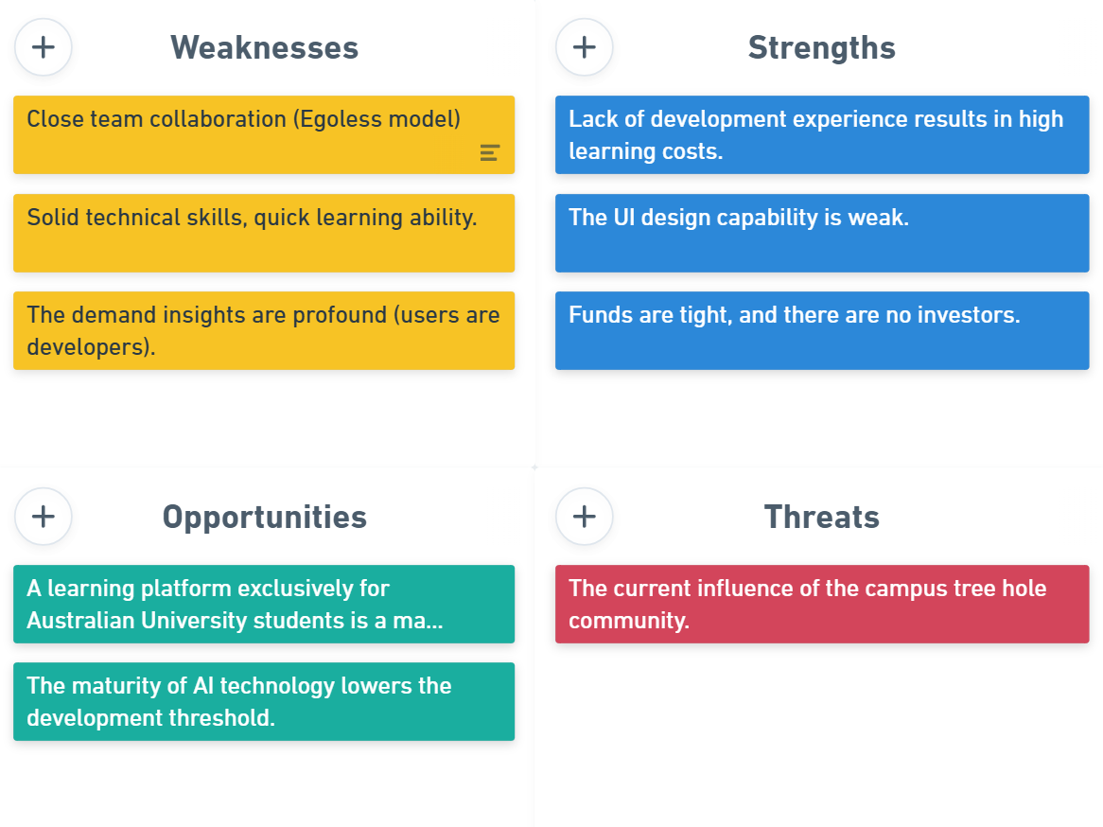

#### Process

1. An inspiring reward system: provides excellent positive feedback, encouraging users to participate more willingly in discussions, ask questions, and answer various aspects beneficial to learning.
2. Precise matching of learning resources: recommends the most relevant study materials and discussion content based on the user's school and major, avoiding interference from irrelevant information.
3. In-depth Q&A community: not only provides answers but also encourages students to engage in deep discussions, supporting senior students to answer questions.
4. International learning support: integrates international academic resources to adapt to the international curriculum system of universities such as the University of Science and Technology.
5. Efficient information management: introduces classification, tagging, and search optimization methods to help students quickly find the necessary study materials and answers to questions.
6. Intelligent recommendation system: analyzes users' learning habits and historical records to recommend the most suitable content.
7. Multiple interaction methods: supports various forms of Q&A communication, including text, voice, images, and code, enhancing the diversity of information expression.

##### **5.1 Functional Requirements**

(1)User registration and identity verification (mobile number + ID card)

(2) Question exchange community (supports text, voice, code, mathematical formulas)

(3) Learning resource sharing (supports upload/download/comments)

(4) AI learning assistant (intelligent question matching, automatic answering, voice recognition)

(5) Reward system (achievements, experience points, badges, active leaderboard)

##### **5.2 Non-Functional Requirements**

(1)High concurrency support ensures a smooth experience.

(2) Data security with encrypted storage of user data.

(3)Compatibility with Android, Apple mobile devices, web platforms, and WeChat mini-programs.

(4) Scalability to support the integration of future new features.

#### **Methods**

**(1)Agile Development Methodology:**

The project will follow an Agile approach, allowing for iterative development and continuous feedback. This will help in adapting to changes quickly and ensuring that the final product meets user requirements.

Sprints will be planned every two weeks, with regular stand-up meetings to track progress and address any blockers.

**(2)User-Centered Design (UCD):**

The design and development process will focus on the needs and preferences of the end-users (MUST students). Regular user testing and feedback sessions will be conducted to refine t he UI/UX.

Prototypes will be created and tested with a small group of users before full-scale development.

**(3)Continuous Integration and Continuous Deployment (CI/CD):**

CI/CD pipelines will be set up to automate the testing and deployment process. This will ensure that new features and bug fixes are integrated and deployed quickly and reliably.

Tools like GitHub Actions or Jenkins will be used for CI/CD.

**(4)Version Control:**

Git will be used for version control, with a repository hosted on GitHub. This will allow the team to collaborate effectively and track changes over time.

Branching strategies like Git Flow will be employed to manage feature development and releases.

**(5)Testing:**

A combination of unit testing, integration testing, and user acceptance testing (UAT) will be conducted to ensure the quality of the application.

Automated testing frameworks like Jest (for JavaScript) or XCTest (for Swift) will be used to streamline the testing process.

**(6)Documentation:**

Comprehensive documentation will be maintained throughout the project, including technical specifications, API documentation, and user manuals.

Tools like Swagger will be used for API documentation.

#### **Programming Language/Frameworks/Tools**

1. **Frontend:** Flutter/SwiftUI  
   **b. Backend:** back4app( Cloud code support: JavaScript/Node.js, Pyhton, Java SDK)  
   **c. Database:** back4app  
   **d. Test:** back4app  
   **e. Auxiliary:** Coze  
    Back4app is a low-code backend platform that simplifies the building of modern applications, which integrates the following features:  
    Databases (real-time capability), cloud code functions, APIs (GraphQL and REST, file storage, authentication, web deployment, push notifications). App development only needs to connect the front-end with it through the methods provided in the back4app documentation, and you can use the back-end and database services provided by back4app, which is suitable for lightweight app development.  
    Coze can directly realize the construction of AI applications, or it can be packaged into an API and called in other software development, or it can be directly packaged into a WeChat mini program to be launched, which is simple and convenient to operate.  
    Flutter is a cross-platform app development framework, which can be used on both Android and Apple systems to develop apps that can be developed in one language, without the need to use different frameworks for different systems, greatly reducing the development workload.

#### **Schedule & Milestones(Gantt)**

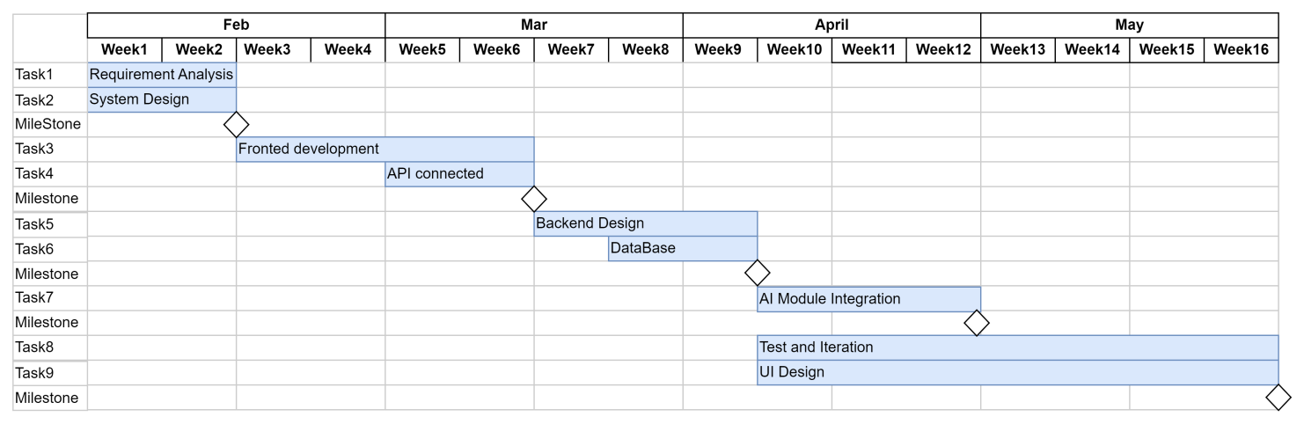

#### **Model Design**

##### **(a) User management module:**

Handles user registration, authentication and profile management.

Supports role-based access control (e.g. student, moderator, administrator).

##### **(b) Q&A Module:**

Allows users to post questions, provide answers and participate in discussions.

Supports rich text formatting, including code snippets and math formulas.

Include a voting system to highlight the best answers.

##### **(c) Resource Sharing Module:**

Allows users to upload and download learning resources (e.g., handouts, past papers).

Contains a commenting system for users to discuss shared resources.

##### **(d) AI Learning Assistant Module:**

Provides intelligent answers using AI models.

Supports Natural Language Processing (NLP) to understand and generate human-like responses.

Integrates with external APIs to provide additional functionality (e.g. Wolfram Alpha for math queries).

##### **(e) Achievement System Module:**

Tracks user activity and rewards achievements (e.g. badges, points).

Include leaderboards to encourage friendly competition between users.

##### **(f)Notification System:**

Sends real-time notifications to users, such as new answers, comments, or achievements.

Supports push notifications for mobile devices.

#### **References**

1. Eric Windmill, Flutter in Action , Manning, 2020.
2. Flutter Chinese Documentation Team. (2024, December 24). Get start in Flutter. Retrieved from <https://docs.flutter.cn/get-started/>
3. Coze Platform Team. (November 20, 2024). Coze Usage Documentation. Retrieved from <https://www.coze.cn/open/docs/guides>
4. CSDN Blog Author. (February 5, 2025). Frontend Dialog Project - Calling ByteDance Coze API. Retrieved from CSDN Blog: <https://blog.csdn.net/m0_55049655/article/details/145450893>
5. CSDN Blog Author. (August 30, 2024). [GPT] Coze Open Platform Interface Usage - API Call. Retrieved from CSDN Blog: <https://blog.csdn.net/weixin_40242845/article/details/141719853>
6. Apple Developer Documentation Team. (2024). SwiftUI - Simplify App Development. Retrieved from Apple Developer Documentation. <https://developer.apple.com/cn/documentation/swiftui/>
7. T. Zhao, "Research on the Network Management System of Students' Art Works based on DB2 Database," 2022 International Conference on Information System, Computing and Educational Technology (ICISCET), Montreal, QC, Canada, 2022, pp. 87-90, doi: 10.1109/ICISCET56785.2022.00030.
8. Y. Zhang and M. van der Schaar, "Influencing the long-term evolution of online communities using social norms," 2011 49th Annual Allerton Conference on Communication, Control, and Computing (Allerton), Monticello, IL, USA, 2011, pp. 306-313, doi: 10.1109/Allerton.2011.6120183.
9. L. Burchard et al., "A Scalable System for Bundling Online Social Network Mining Research," 2020 Seventh International Conference on Social Networks Analysis, Management and Security (SNAMS), Paris, France, 2020, pp. 1-6, doi: 10.1109/SNAMS52053.2020.9336577.
10. B. Ujkani, D. Minkovska and L. Stoyanova, "A recommender system for WordPress themes using item-based collaborative filtering technique," 2020 XXIX International Scientific Conference Electronics (ET), Sozopol, Bulgaria, 2020, pp. 1-3, doi: 10.1109/ET50336.2020.9238305. keywords: {Filtering;Collaborative filtering;Prediction algorithms;Recommender systems;Consumer electronics;recommender system;collaborative filtering;WordPress;marketplace},
11. J. J. Chang, N. S. Hildayah binti Zahari and Y. H. Chew, "The Design of Social Media Mobile Application Interface for the Elderly," 2018 IEEE Conference on Open Systems (ICOS), Langkawi, Malaysia, 2018, pp. 104-108, doi: 10.1109/ICOS.2018.8632701.
12. A. Chin et al., "Using Proximity and Homophily to Connect Conference Attendees in a Mobile Social Network," 2012 32nd International Conference on Distributed Computing Systems Workshops, Macau, China, 2012, pp. 79-87, doi: 10.1109/ICDCSW.2012.56.